NAME ……………………………………………………………………..………….………………….… INDEX NO……………………………………… SIGNATURE………..……………………………….

P/S850/1  
**Subsidiary Information and  
Communication Technology  
PAPER 1**July/August 2019  
Time:2 ½ hours



WESTERN JOINT MOCK EXAMINATIONS

Uganda Advanced Certificate of Education

**SUBSIDIARY ICT  
Paper 1**2Hours 30 Minutes

**INSTRUCTIONS TO CANDIDATES:**

* *The paper is made up of* **20** *equally weighted questions.*
* *Answer* **all** *questions in this paper.*
* **All** *answers should be written in dark blue or black ink in the spaces provided on the question paper.*
* ***No*** *additional answer sheets should be inserted.*

| **For examiner’s use only** | | | | | | | | | | | | | | | | | | | | |
| --- | --- | --- | --- | --- | --- | --- | --- | --- | --- | --- | --- | --- | --- | --- | --- | --- | --- | --- | --- | --- |
| 1 | 2 | 3 | 4 | 5 | 6 | 7 | 8 | 9 | 10 | 11 | 12 | 13 | 14 | 15 | 16 | 17 | 18 | 19 | 20 | **Total** |
|  |  |  |  |  |  |  |  |  |  |  |  |  |  |  |  |  |  |  |  |  |

1. (a) Define the term Computer trouble shooting *(01 Mark)*

……………………………………………………………………………………………………..

…………………………………………………………………………………………………..…

……………………………………………………………………………………………..…………

(b) Give three ways how you can troubleshoot a computer that has failed to start.

*(03marks)*

……………………………………………………………………………………………..………

…………………………………………………………………………………………………..…

………………………………………………………………………………………………………

………………………………………………………………………………………………………

(b) Give one factor one should consider before buying a computer *(01 Marks)*

………………………………………………………………………………………………………

………………………………………………………………………………………………………

2. (a) Give the difference between Data and Information *(01 Mark)*

………………………………………………………………………………………………………

………………………………………………………………………………………………………

………………………………………………………………………………………………………

………………………………………………………………………………………………………

(b) List two reasons to justify the need for information processing *(02 Marks)*

………………………………………………………………………………………………………

………………………………………………………………………………………………………

(c) State two examples of information in a school setup. *(02 Marks)*

………………………………………………………………………………………………………

………………………………………………………………………………………………………

………………………………………………………………………………………………………

………………………………………………………………………………………………………

3. (i) What is a computer laboratory?  *(1Mark)*

………………………………………………………………………………………………………

………………………………………………………………………………………………………

………………………………………………………………………………………………………

………………………………………………………………………………………………………

(ii) List down any four devices used for maintaining computers in sound condition.

*(4 Marks)*

………………………………………………………………………………………………………

………………………………………………………………………………………………………

………………………………………………………………………………………………………

………………………………………………………………………………………………………

4. Before the examination day, students were not allowed in the computer lab because the lab technician was handling routine maintenance of computers.

(a) What do you understand by the term computer maintenance? *(02 marks)*

………………………………………………………………………………………………………

………………………………………………………………………………………………………

………………………………………………………………………………………………………

………………………………………………………………………………………………………

(b) During the maintenance process, some computers failed to boot, mention any

two causes of the boot failure. *(02 marks)*

………………………………………………………………………………………………………

………………………………………………………………………………………………………

(c) Define booting *(01 mark)*

………………………………………………………………………………………………………

………………………………………………………………………………………………………

5. (a) Use the image below to answer the questions that follow

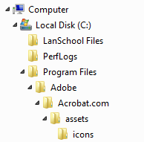

1. Write down the path for the subfolder called **icons** *(2 marks)*

…………………………………………………………………….………………………..………

…………….…………………………………………………………………….……………….…

1. Write down three methods you can use to recover an accidentally deleted folder from the desktop *(3 marks)*
2. …………………………………………………………………………………………………
3. …………………………………………………………………………………………………
4. …………………………………………………………………………………………………

6. (a) Clare received a file with the following name; “exams.ppt”. What name is given to

the part **.ppt**.? *(01 mark)*

…………………………………………………………………….……………………..…………

……………………………………………………………………..…………….…………………

(b) What does part **.ppt** stand for? . *(01 mark)*

…………………………………………………………………………………………………………

(c) What is the function of the part **ppt**.? *(02 marks)*

…………………………………………………………………………………………………………

…………………………………………………………………………………………………………

(d) He wanted to change the name of the file, he right clicked, What command did he choose? *(01 mark)*

………………………………………………………………………………………………………

………………………………………………………………………………………………………

7. (a) Define computer hardware *(02 marks)*

………………………………………………………………………………………………………

………………………………………………………………………………………………………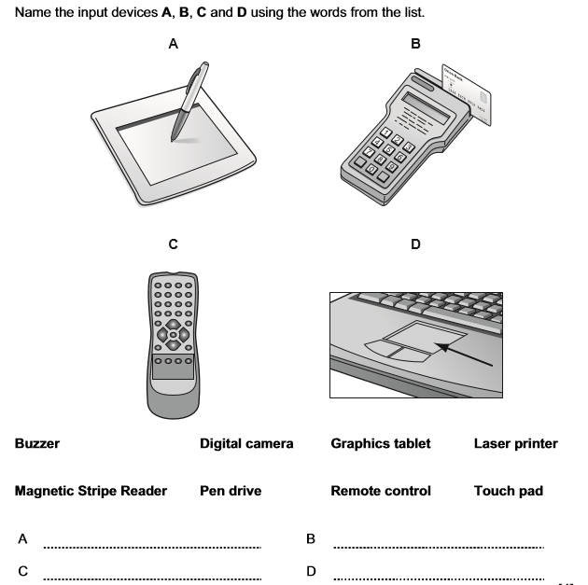

…



8. (a) Give two examples of Central Processing Unit of a computer you know *(2 marks)*

………………………………………………………………………………………………………

………………………………………………………………………………………………………

(b) Give the role of each of the following Central Processing Unit components. *(3 marks)*

i. Bus

………………………………………………………………………………………………………

………………………………………………………………………………………………………

ii. Control unit

………………………………………………………………………………………………………

………………………………………………………………………………………………………

iii. Registers

………………………………………………………………………………………………………

………………………………………………………………………………………………………

9. (a) Identify any two advantages of using digital camera over a film camera*. (02 marks)*

………………………………………………………………………………………………………

………………………………………………………………………………………………………

b) Give three causes of printer failure

………………………………………………………………………………………………………

………………………………………………………………………………………………………

10. (a) Define the term Application software. *(02 marks)*

………………………………………………………………………………………………………

………………………………………………………………………………………………………

(b) Give one example of Application software used in communication. *1 mar)*

………………………………………………………………………………………………………

………………………………………………………………………………………………………

(c) List down two categories of Application software.  *(02 marks)*

………………………………………………………………………………………………………

…………………………………………………………………………………………………………

11. (a) Differentiate between “Cropping” from “Crop marks” features of desktop

publishing software *(01 Mark)*

…………………………………………………………………………………………………………

…………………………………………………………………………………………………………

(b) List two publications that can be made using desktop publishing software.

*(02 Marks)*

………………………………………………………………………………………………………

………………………………………………………………………………………………………

(c) List two features of desktop publishing software. *(02 Marks)*

………………………………………………………………………………………………………

………………………………………………………………………………………………………

12. (a) What is spooling? *(01 Mark)*

………………………………………………………………………………………………………

………………………………………………………………………………………………………

(b) Distinguish between customized software and canned software *(02 Marks)*

………………………………………………………………………………………………………

………………………………………………………………………………………………………

(c) State the meaning of the following

(i) Shareware

………………………………………………………………………………………………………

………………………………………………………………………………………………………

(ii) Freeware

………………………………………………………………………………………………………

………………………………………………………………………………………………………

13. (a) Define the term internet browser. *(01 mark)*

………………………………………………………………………………………………………

………………………………………………………………………………………………………

(b) State two examples of browsers you know. *(2marks)*

………………………………………………………………………………………………………

………………………………………………………………………………………………………

(c) Write short notes on the following:

(i). Search engine. *(01 mark)*

………………………………………………………………………………………………………

………………………………………………………………………………………………………

(ii) Wiki  *(01 mark)*

………………………………………………………………………………………………………

………………………………………………………………………………………………………

14. (a) Explain the term Netiquette as used in Information Technology *(02 marks)*

………………………………………………………………………………………………………

………………………………………………………………………………………………………

(b) Give three ways how you can exercise netiquette. *(3marks)* ………………………………………………………………………………………………………

………………………………………………………………………………………………………

15. (a) Define the term website. *(01 mark)*

………………………………………………………………………………………………………

………………………………………………………………………………………………………

(b) Give two ways how a website can be of importance to your school. (*2 marks)*

………………………………………………………………………………………………………

………………………………………………………………………………………………………

(c) Give two ways how a website can be of a disadvantage to your school. *(2marks)*

………………………………………………………………………………………………………

………………………………………………………………………………………………………

16. (a) Define the following terms.

(i) Data communication *(01 mark)* ………………………………………………………………………………………………………

………………………………………………………………………………………………………

(ii) Protocol *(01 mark)*

………………………………………………………………………………………………………

………………………………………………………………………………………………………

(b) List three elements of data communication. (*3marks)*

………………………………………………………………………………………………………

………………………………………………………………………………………………………

………………………………………………………………………………………………………

17. (a) (i) Define data transmission media. *(01 mark)*

………………………………………………………………………………………………………

………………………………………………………………………………………………………

(b) (i)) Give one example of transmission media. *(01 mark)*

………………………………………………………………………………………………………

(c) Give three advantages of electronic data transmission over manual means.

*(3mark)* ………………………………………………………………………………………………………

………………………………………………………………………………………………………

………………………………………………………………………………………………………

18 (a) Explain the following concepts as used in Information Technology.

(i) Green computing. *(01mark)* ………………………………………………………………………………………………………

………………………………………………………………………………………………………

(ii) Intellectual property rights. *(01 mark)*

………………………………………………………………………………………………………

………………………………………………………………………………………………………

(b) Explain three ways of maintaining Green computing by organisations. *(3mks)* ………………………………………………………………………………………………………

……………………………………………………………………………………………………

19. Use the following spreadsheet chart to answer questions below:

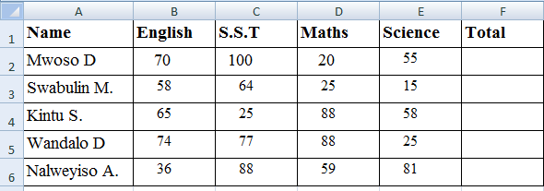

(a). Write the data type used in the range B2:B6? *(01 mark)*

………………………………………………………………………………………………………

(b) write a formula to compute an average mark for Nalweyiso? *(01 mark)*

…………………………………………………………………………………………………………

(c) How many cells are in the range A2:C6? *(01 mark)*

………………………………………………………………………………………………………

………………………………………………………………………………………………………

(d). State two ways data in cell range A1:D1 can be emphasized? *(2marks)*

………………………………………………………………………………………………………

…………………………………………………………………………………………………………

20. (a) Define the following terms as used in database programming:

(i). Record *(01 mark)*

………………………………………………………………………………………………………

………………………………………………………………………………………………………

(ii) Field *(01 mark)*

……………………………………………………………………………………………………… ………………………………………………………………………………………………………

(iii) Database *(01 mark)*

………………………………………………………………………………………………………

………………………………………………………………………………………………………

(b) State two advantages of using an electronic database over a manual database.

*(2marks)*

……………………………………………………………………………………………………… …..…………………………………………………………………………………………………

………………………………………………………………………………………………………

**END**